**Introduction to HTML/CSS**

1.How are inline and block elements different from each other?

Ans: An inline block does not create a line break while block element always starts with a new line and take full width of page.

Inline: <a>, <span>, <img> etc.

Block: <div>, <p>, etc

2.Explain the difference between visibility:hidden and display:none

Ans: They both do the same work of hiding the element but Visibility: hidden makes an element of the attribute but space is still allocated for attribute.

While with Display:none space is not allocated for that element.

3. Explain the clear and float properties.

Clear: property specifies what elements can float beside the cleared element and on which side.

Float: property specifies how an element floats, it is used for positioning and layout of webpages.

4. Explain the difference between absolute, relative,fixed and static.

Static: default positioning of elements, not affected by top, bottom, left and right properties.

Fixed: It is positioned relative to the viewport which means it stays in the same place even if the page is scrolled.

Relative: position of elements is relative to its normal position. Gives the freedom to set at any position.

Absolute: is positioned relative to the nearest positioned ancestor, thereby using the document body.

5. Write the HTML code to create a table in which there are 4 columns( ID , Employee Name, Designation, Department) and at least 6 rows. Also do some styling to it.

6. Why do we use meta tags?

Meta means data within a data. It provides meta data about the HTML elements. They are typically used to specify page description,keywords etc. HTML 5 has introduced viewport for better interaction and responsiveness.

7. Explain box model.

It is essentially a box that wraps every HTML element. Consist of:

Content: content of the box where images and text appear

Padding: clears the area around the content. It is transparent

Border: border that goes around the padding and content

Margin:clears the area outside the border

8. What are the different types of CSS Selectors?

CSS Selectors are used to select the content you want to style. Different types of selectors are:

Element selector: selects the HTML by name.

Id selector: selects the id attribute of an element to select a specific element.

Class selector: selects elements with a specific class attribute.

Universe selector: used as a wildcard and selects all elements on the page.

Group selector: used to select all the elements with the same style definitions.

9. Define Doctype.

This tag is an instruction to the web browser to tell about what the version is to be used about the Current HTML version to be used.

10. Explain 5 HTML5 semantic tags.

Section: It is used to represent a part of a webpage consisting of articles.

Article: It encloses stories or text and usually comes under the Section tag.

Hgroup: It represents a group of headers.

Nav: it represents navigation bars consisting different tabs

Footer: As name suggests, it is the bottom part of a webpage consisting copyright information and navigation information

11. Create HTML for web-page.jpg (check resources, highest weightage for answers)

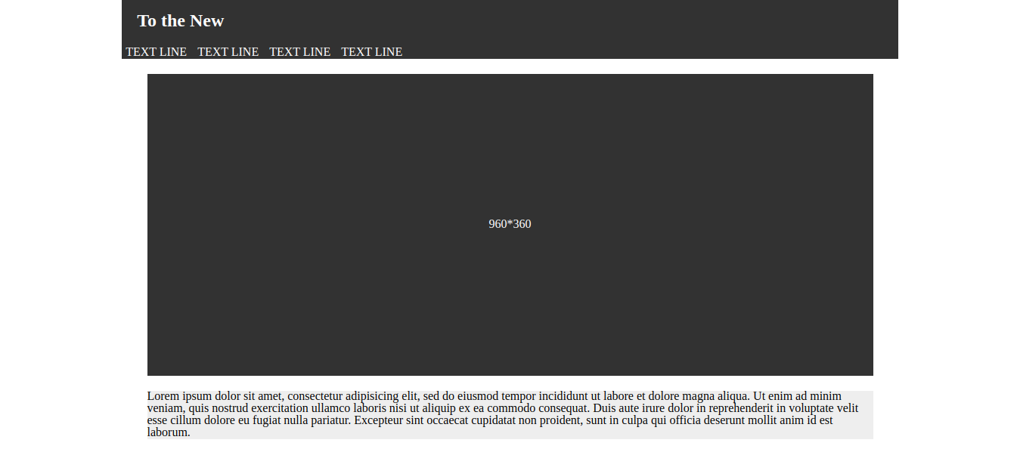

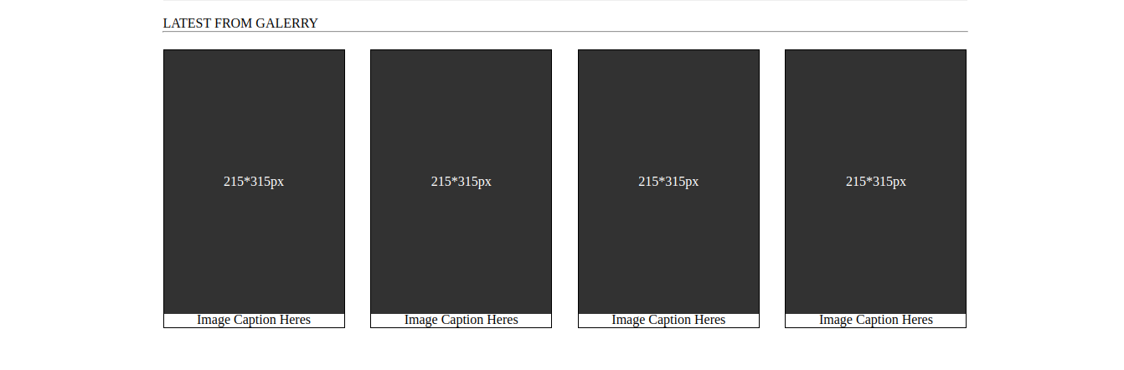

12. Create HTML for form.png (check resources, highest weightage for answers)

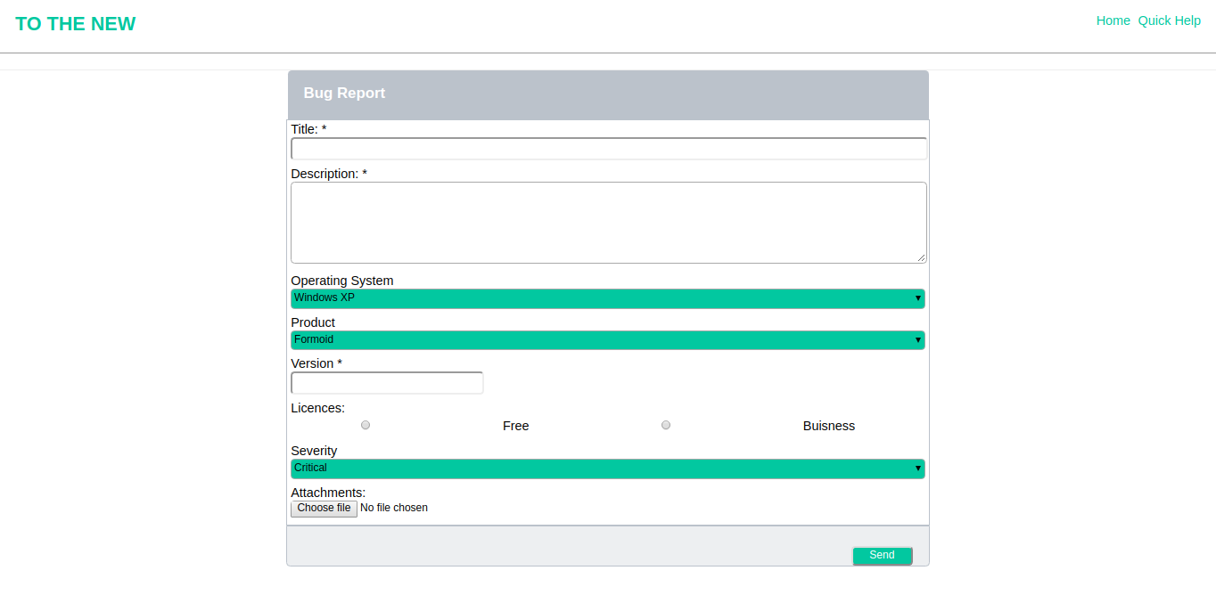

Code: In Git repo